

**LA GRANDEE INTERNATIONAL COLLEGE**

**Simalchaur, Pokhara Nepal**

AMid-term Progress Report

On

**“Freelancing Platform”**

**Submitted to:**

Bachelor of Computer Application (BCA) Program

In partial fulfilment of the requirements for the degree of BCA under Pokhara University

**Submitted by:**

|  |  |  |  |
| --- | --- | --- | --- |
| **Name:** | **Course** | **Semester** | **P.U. Registration Number** |
| Anish Baniya | BCA | 6th | 2021-1-53-0347 |
| Sabin Gurung | BCA | 6th | 2021-1-53-0352 |
| Suyan Thapa | BCA | 6th | 2021-1-53-0371 |

**Date:12/26/2024**

# Table of Contents

Table of Figures iii

1. Introduction 1

2. Problem Statement 2

3. Objectives 3

4. Completed 4

5. Methodology 5

6. System Design 8

7. Project Gantt chart 10

8. Bottlenecks 11

9. References 12

# Table of Figures

5.1: Agile Methodology 5

6.1:Gantt Chart 9

# Introduction

A Freelance Marketplace System is an innovative web-based platform designed specifically to connect the freelancers with businesses seeking specialized services. The marketplace aims to create dynamic online environment where freelancers can showcase their skills and offer services, while clients can browse, and easily find the right professionals for their projects according their needs. This system streamlines the process of hiring the freelancers and enables efficient management of service-based tasks.

The FMS is being developed with the aim of creating a unified platform where freelancers from various fields such as design, development, writing, digital marketing and many more can advertise their services to a global audience. Clients, ranging from small businesses to large enterprises, can search for the appropriate skill sets, request services, and manage project timelines within the platform. By offering various service categories, the system allows clients to filter through relevant freelancers based on ratings, reviews, pricing, and expertise.

 The Freelance Marketplace project serves as a vital tool to create a vibrant online ecosystem where talent meets opportunity. By bridging the gap between talent and demand, it not only supports individual careers but also contribute to the growth of the freelance economy as a whole.

# Problem Statement

In the context of our country, there are no sufficient online platforms that particularly focuses on micro-jobs. Majority of the available online job platforms recruits individual for mainstream/career jobs such as teaching, banking etc. Most of the Nepalese freelancers prefer to work on global online marketplace for freelance services such as Fiverr, Upwork, etc. due to unavailability of such reliable gig marketplace. Most of the online freelancing web app allows freelancers for bidding which creates a cut-throat competition among freelancers. (Bibek Ranabhat, 2023)

* Lack of Nepali Payment Gateways (Khalti, Esewa)
* Poor UI/UX Design

# Objectives

Freelance marketplaces are amongst the fastest-evolving platforms, encouraged technology, which have revolutionized the way business entities and freelancers meet. With the demand for digitized services and remote work on a continuous rise, the appropriate FMS will make the process much easier and smoother for both freelancers and clients alike. Accordingly, if one gets hold of an appropriate platform, they can then smoothly go about managing their outsourcing requirements, while freelancers are in a position to present their skills and acquire work with a whole lot of simplicity.

* To implement the reliable local payment gateways.
* To improve the design of the platform.

# Completed

In the mid-term phase of our freelance marketplace project, we successfully completed the first two sprints out of the planned five.

**Sprint 1** focused on building the foundational features of the platform, including user registration, login, and the initial dashboard. These features established the core structure of the platform, allowing users to create accounts, log in securely, and access the basic interface.

**Sprint 2** concentrated on designing and implementing the freelancer profile and skills section. This enabled freelancers to create detailed profiles, showcase their skills, and upload portfolios to highlight their expertise. These functionalities are critical for connecting freelancers with potential clients and ensuring a seamless experience for both parties.

With these two sprints completed, the project has laid a solid foundation for further development. The remaining three sprints will focus on implementing advanced features such as job postings, search functionalities, payment integrations, and overall platform refinement. This progress reflects our commitment to delivering a functional and user-friendly freelance marketplace.

# Methodology

A methodology is a series of processes or phases, which helps you define which stage you are at the given period. A set of procedures or methods to develop software is known as software development methodology. Methodology shapes a structure of software thus it is important to precisely choose the required method to develop software. In Context of our project, we have chosen the Agile Methodology. Unlike traditional linear methods, Agile breaks project activities into iterative phases, where each phase involves continuous collaboration and is adaptable to changes. Each iteration builds upon the previous one, allowing for flexibility and continuous improvement throughout the development process.

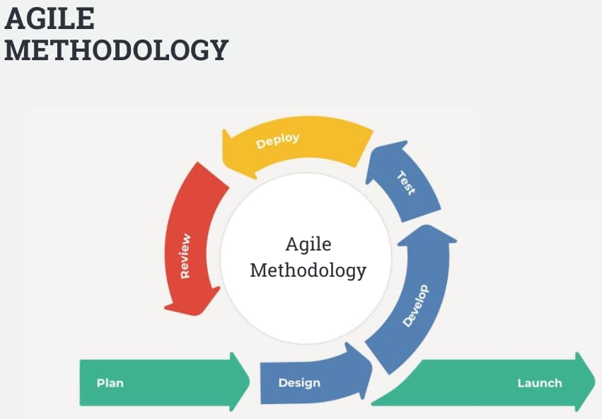 (interquality, 2024)

5.1: Agile Methodology

Agile methodology is a process that helps teams manage and complete projects in an iterative, flexible manner. It involves several key stages that are repeated in each sprint, allowing for continuous improvement and adaptability. Below is an overview of the stages in Agile methodology:

1. Plan:

This phase involves defining the scope of the sprint. The team selects tasks from the project backlog and sets objectives for what should be delivered by the end of the sprint.

1. Design:

Once planning is complete, the team creates detailed designs or wireframes for the selected tasks. This ensures the technical and user experience aspects are clear before development begins.

1. Develop:

In the development phase, the team writes the code for the features defined in the plan and design stages. This includes both frontend and backend development.

1. Test:

After development, the testing phase ensures that the new code works as expected. Bugs and issues are identified and fixed before moving on.

1. Deploy:

The deploy phase involves making the working software available to users. In each sprint, the team delivers a usable part of the software.

1. Review:

During the sprint review, stakeholders provide feedback on the completed work. This feedback is used to improve future sprints.

1. Launch:

During the sprint review, stakeholders provide feedback on the completed work. This feedback is used to improve future sprints.

The project will be divided into five sprints, each focusing on specific aspect of our freelance marketplace project:

* Sprint 1:

Plan and develop the basic features such as user login, registration, and the initial dashboard. This provides the fundamental structure for users to create accounts and access the platform.

* Sprint 2:

Design and implement the freelancer profile and skills section, where freelancers can create and showcase their profiles, skills, and portfolios.

* Sprint 3:

Integrate the payment gateways such as Khalti and Esewa, allowing secure transactions within the platform.

* Sprint 4:

Add job posting functionality for clients to post their projects and the review system where freelancers can be rated and reviewed based on their performance.

* Sprint 5:

Perform final testing, fix any bugs, and conduct a full deployment of the platform. This ensures the platform is functional and ready for users.

# System Design

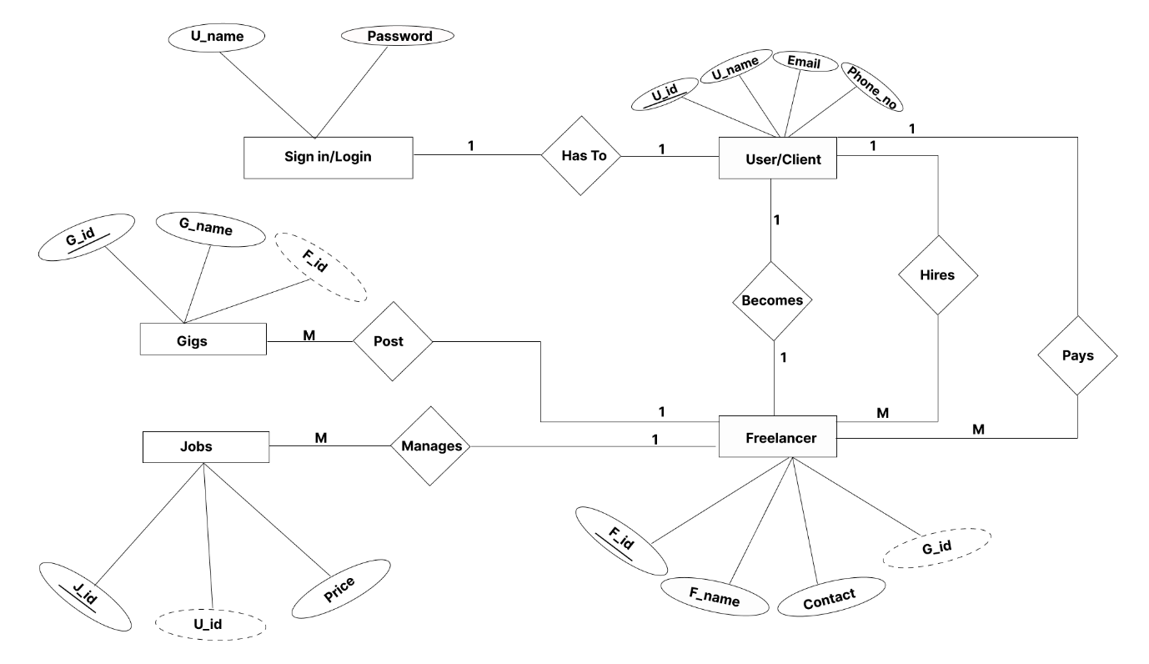

6.1:ER Diagram

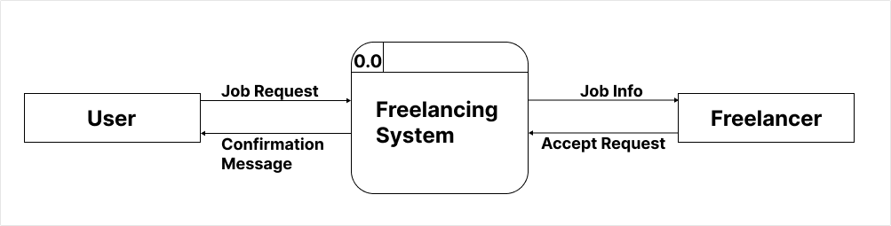

6.2: LVL 0 DFD

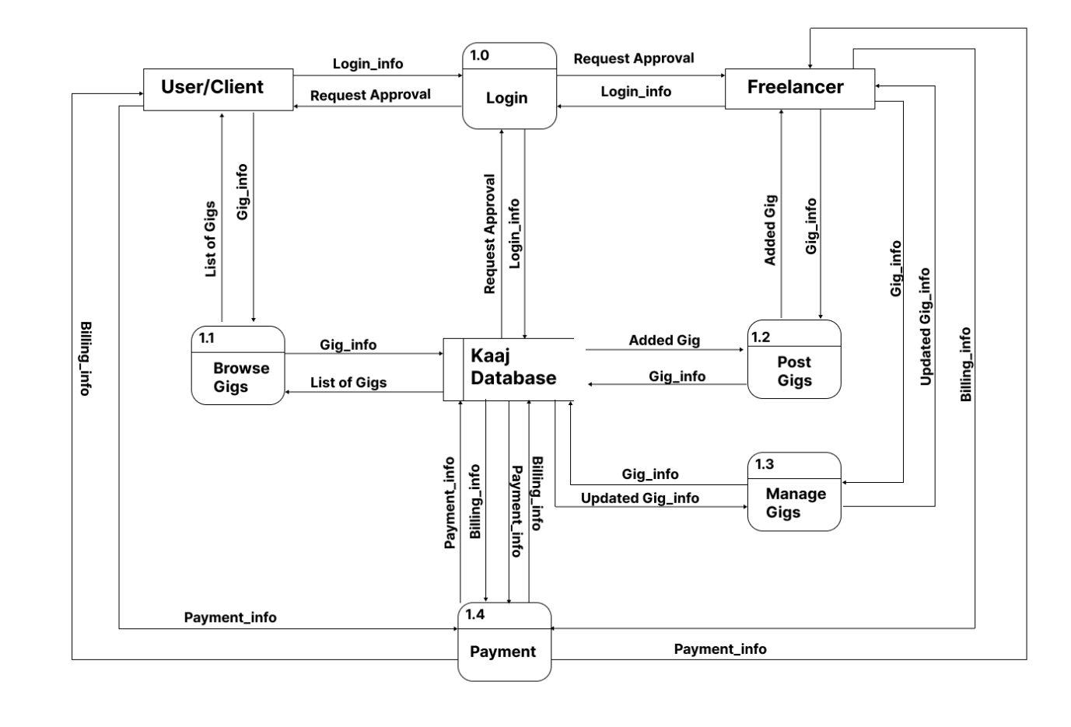

6.3: DFD LVL 1

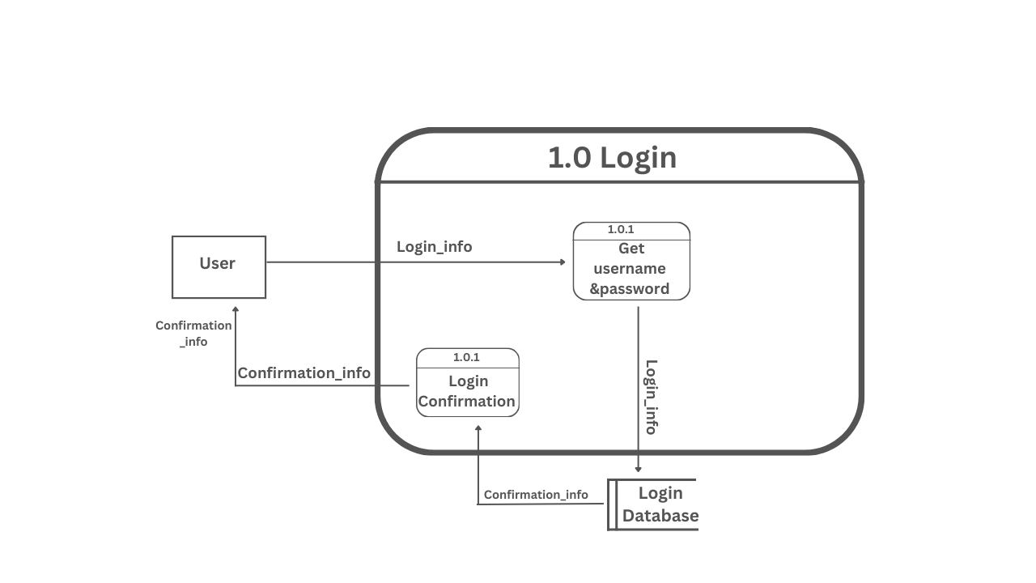

6.4: DFD LVL 2

# Project Gantt chart

A Gantt chart is a popular project management tool used to visualize the schedule of a project. It displays tasks or activities against time, allowing project managers to track progress, manage dependencies, and allocate resources efficiently.

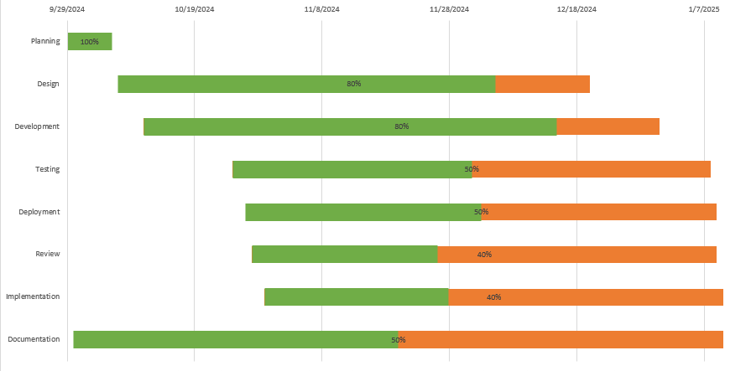

7.1:Gantt Chart

# Bottlenecks

During the development phase of our freelance marketplace project, we encountered several bottlenecks that temporarily slowed down progress. These challenges were identified and resolved, ensuring the project remained on track. Below are the key bottlenecks and how they were addressed:

* **Authorization Challenge:**

Early in the project, we faced issues while implementing the authorization section. This created a delay in progress, as proper user authentication is critical for the platform’s security. However, through focused debugging and adjustments, we successfully resolved the issues and completed the authorization module, ensuring it met the required functionality and security standards.

* **Single CSS File for All Pages**:

Initially, a single CSS file was being used for styling across all pages. This approach led to challenges in managing styles, as changes in one section could unintentionally affect others. To address this, we reorganized the styling structure by creating separate CSS files for individual pages, which improved maintainability and modularity.

* **Single File Connected to Multiple Modules**:

One of the backend files was connected to multiple other files, creating complexity and dependency issues during development. This bottleneck was resolved by restructuring the codebase, ensuring that each module or file had clearly defined responsibilities. This improved code readability, modularity, and maintainability.

# References

Bibek Ranabhat, E. A. (2023). *computer-science*. Retrieved from coursesidekick: https://www.coursesidekick.com/computer-science/3357592

interquality. (2024). *agile-methodology*. Retrieved from interqualitybg: https://interqualitybg.com/en/resources/scrum-and-agile-resources/agile-methodology